Student Performance Predictor

Introduction:-

In the modern education system, predicting student performance has become an important tool for teachers, parents, and educational institutions. Accurate predictions can help identify students who may need additional support and optimize their learning. This project aims to develop a simple predictive system that can tell whether a student will pass or fail based on the amount of time they spend on their academics (study hours).

The Student Performance Predictor is built using the Python programming language and implements linear regression to model student outcomes. The project uses fundamental concepts in AI/ML, including data preprocessing, model training, and prediction.

Objective:-

The main objectives of the project are:
  - Predict whether a student will pass or fail based on historical performance data.
  - Apply linear regression, to a real-world dataset.
  - Learn how to prepare, train, and evaluate a predictive model.

Tools and Technologies Used:-
- Python 3.14 – main programming language.
- Spyder IDE – for coding and testing.
- CSV (Comma-Separated Values) – to store student data.
- Linear Regression – machine learning model to predict outcomes.
- Git and GitHub – version control and repository management.

Project Structure:-
The project has the following structure:-

Student Performance Predictor/
├── Source code/
│
│
├── main.py
└── model.py
├── data/
│
└── students.csv
├── README.md
└── Project_Report.pdf

Data set

My data set includes data.csv:-

Feature name | Description
Study hours | No of hours a student studies
Attendance | Attendance percentage
Marks | Marks scored in tests

Example rows:-

Study hours | Attendance | Marks
2 | 60 | 45
3 | 65 | 50
4 | 70 | 55
5 | 75 | 60
6 | 80 | 65

Note:-
The Pass/Fail label is derived from marks (e.g., marks >= 50 = Pass, marks < 50 = Fail).

Methodology:-
- Load the data from the CSV file.
- Preprocess the data (add a Pass/Fail column based on marks).
- Train a linear regression model using study_hours, attendance, and marks as input features.
- Predict whether a student will pass or fail.
- Evaluate the model’s performance.

How to Run:-

Step 1:- Clone the repository by opening command prompt
git clone https://github.com/Pushkar10105/Student- performance-predictor.git

Step 2:- Navigate to the source folder
cd Student-performance-predictor/”Source code”

Step 3:- Run the program
python main.py

Screen shots :-
First when we run the program we get a menu interface asking us to input the hours studied by a student
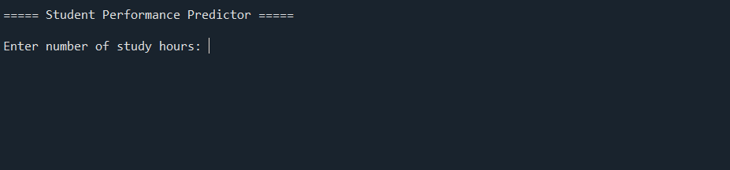

Then now we can enter the requested data and see what our model predicts
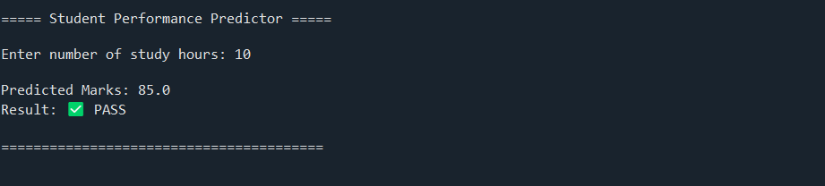

This is our final working of our model

Conclusion
This project demonstrates how linear regression can help predict student pass/fail outcomes. It provides hands-on experience with Python, CSV handling, and basic machine learning concepts, while allowing practical application of study data.
Developing this project was a very fun and immersive practical learning experience i got to use linear regression in this project
Finally this project was Developed by:-
Nitish Sharma
Registration no:- 25BAI10534

